Private Clairus Riggs
Company B, 1st Battalion, 116th Infantry Regiment, 29th Infantry Division
Omaha Beach

1940 Census
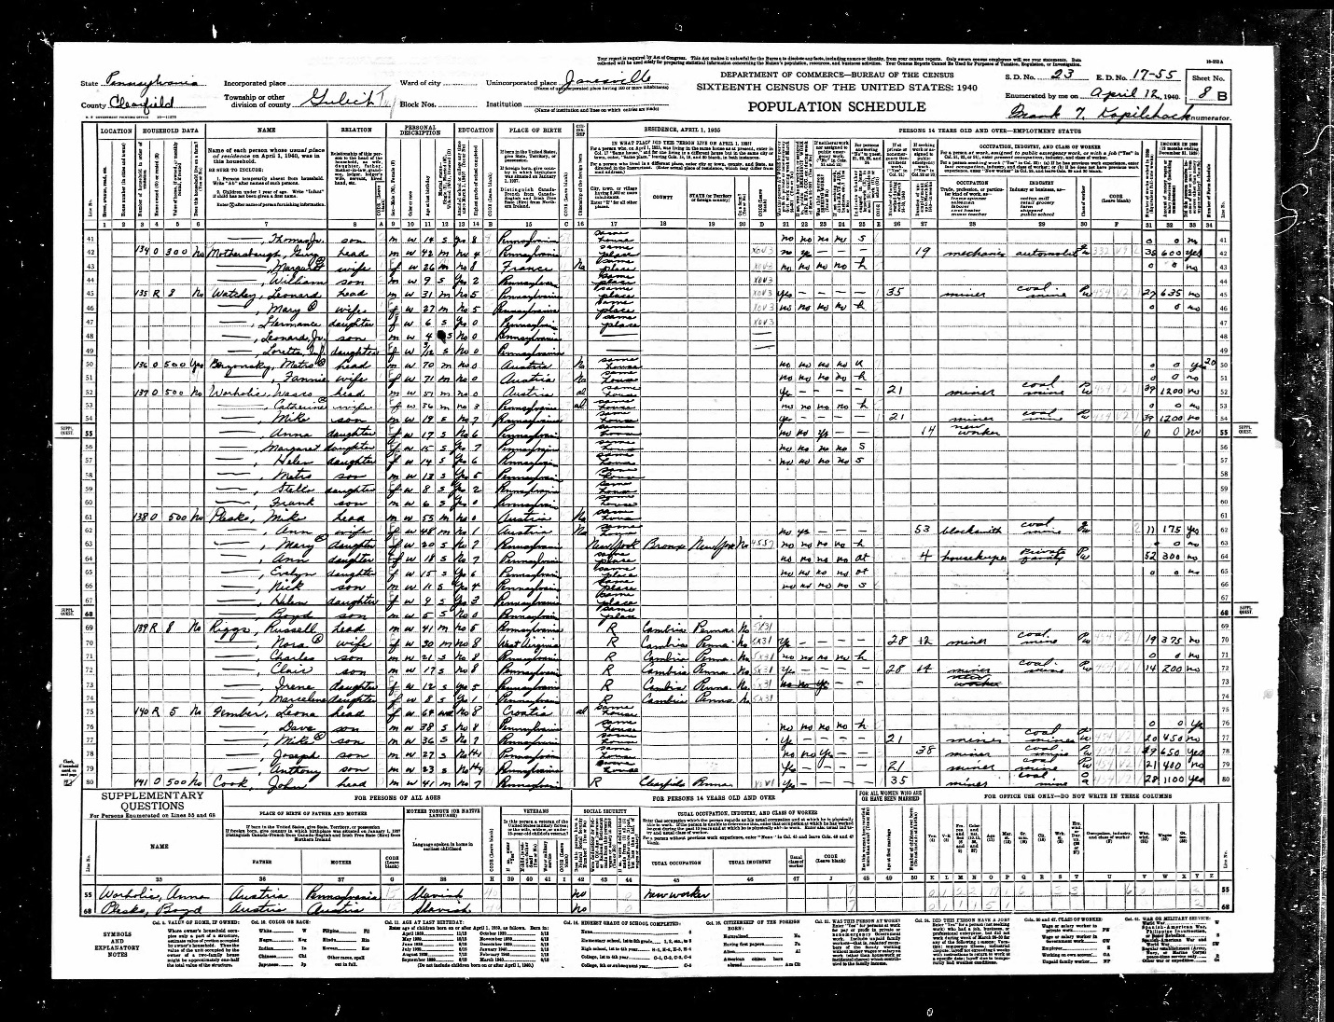

Draft Registration Card
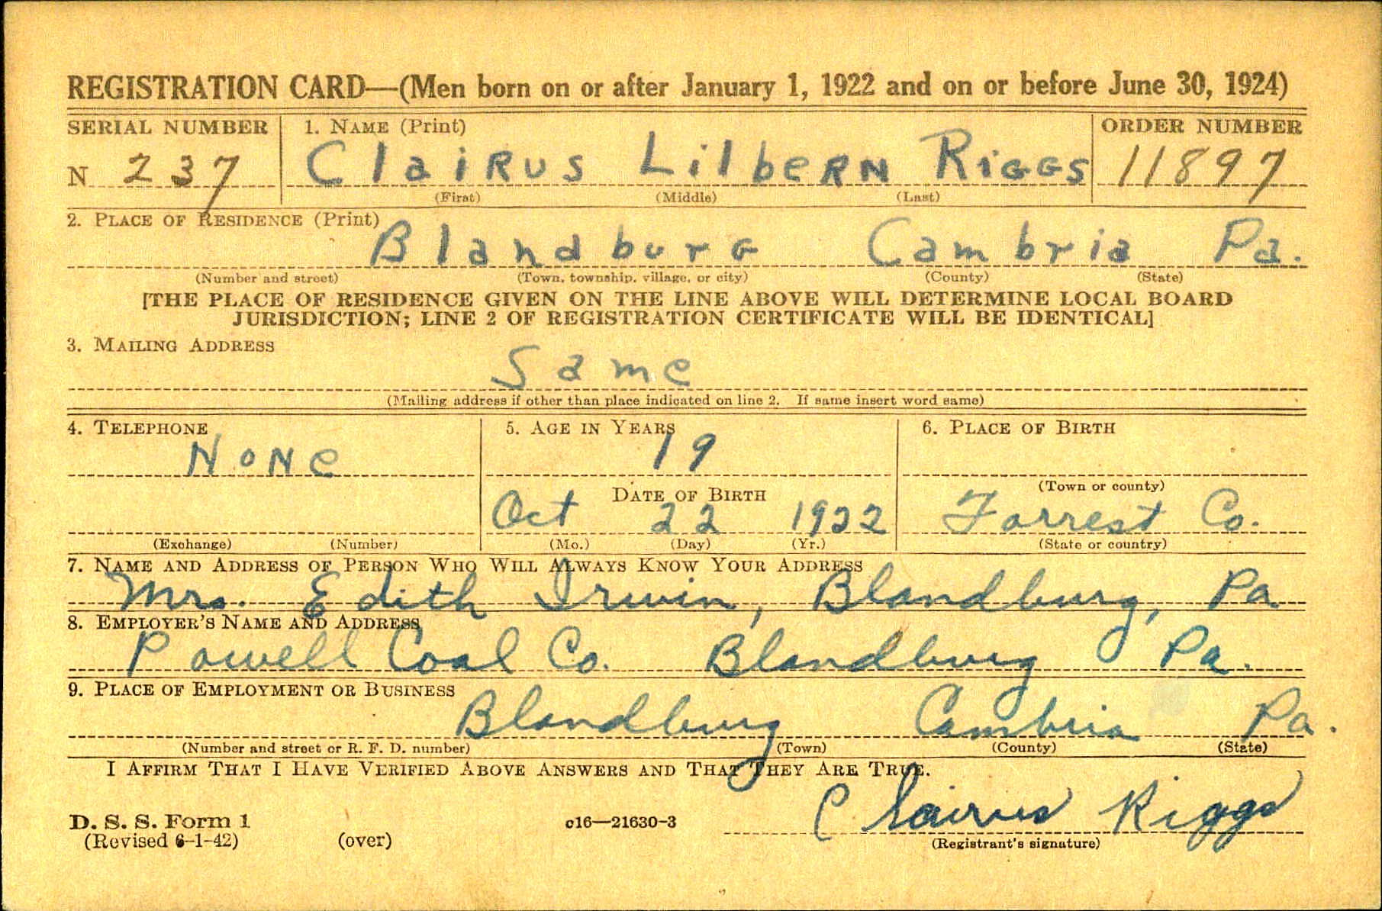

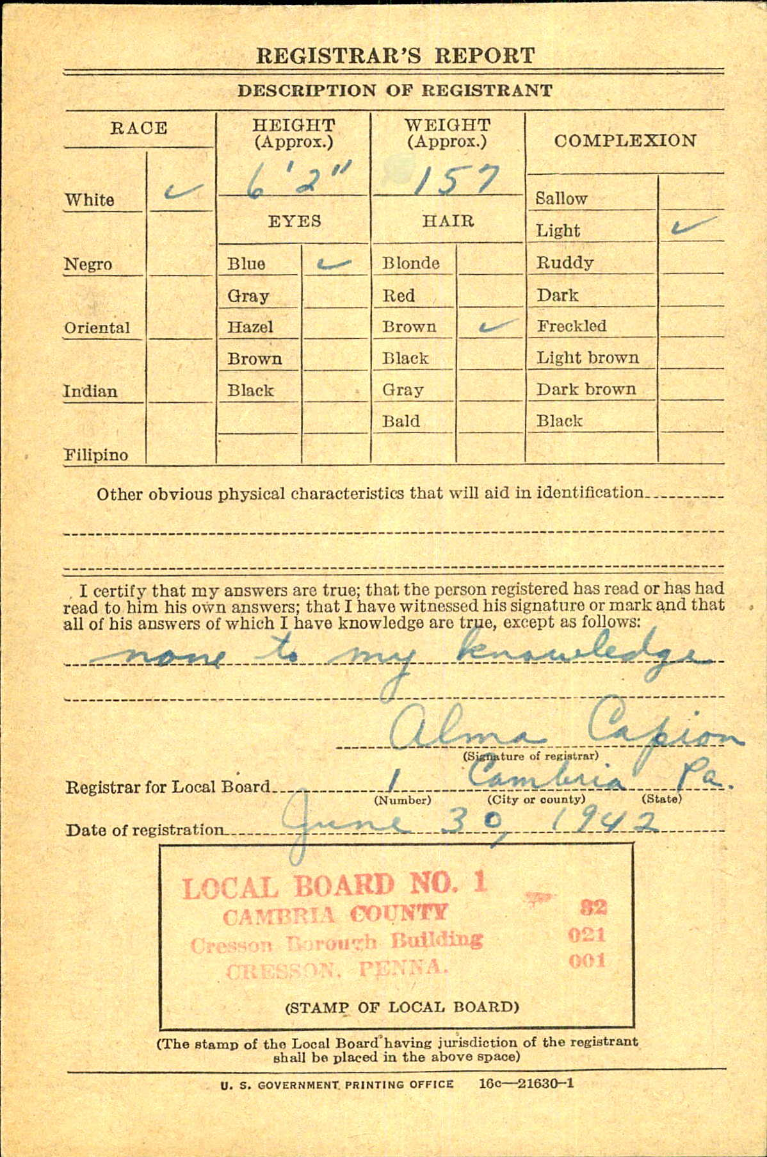
Pension Application
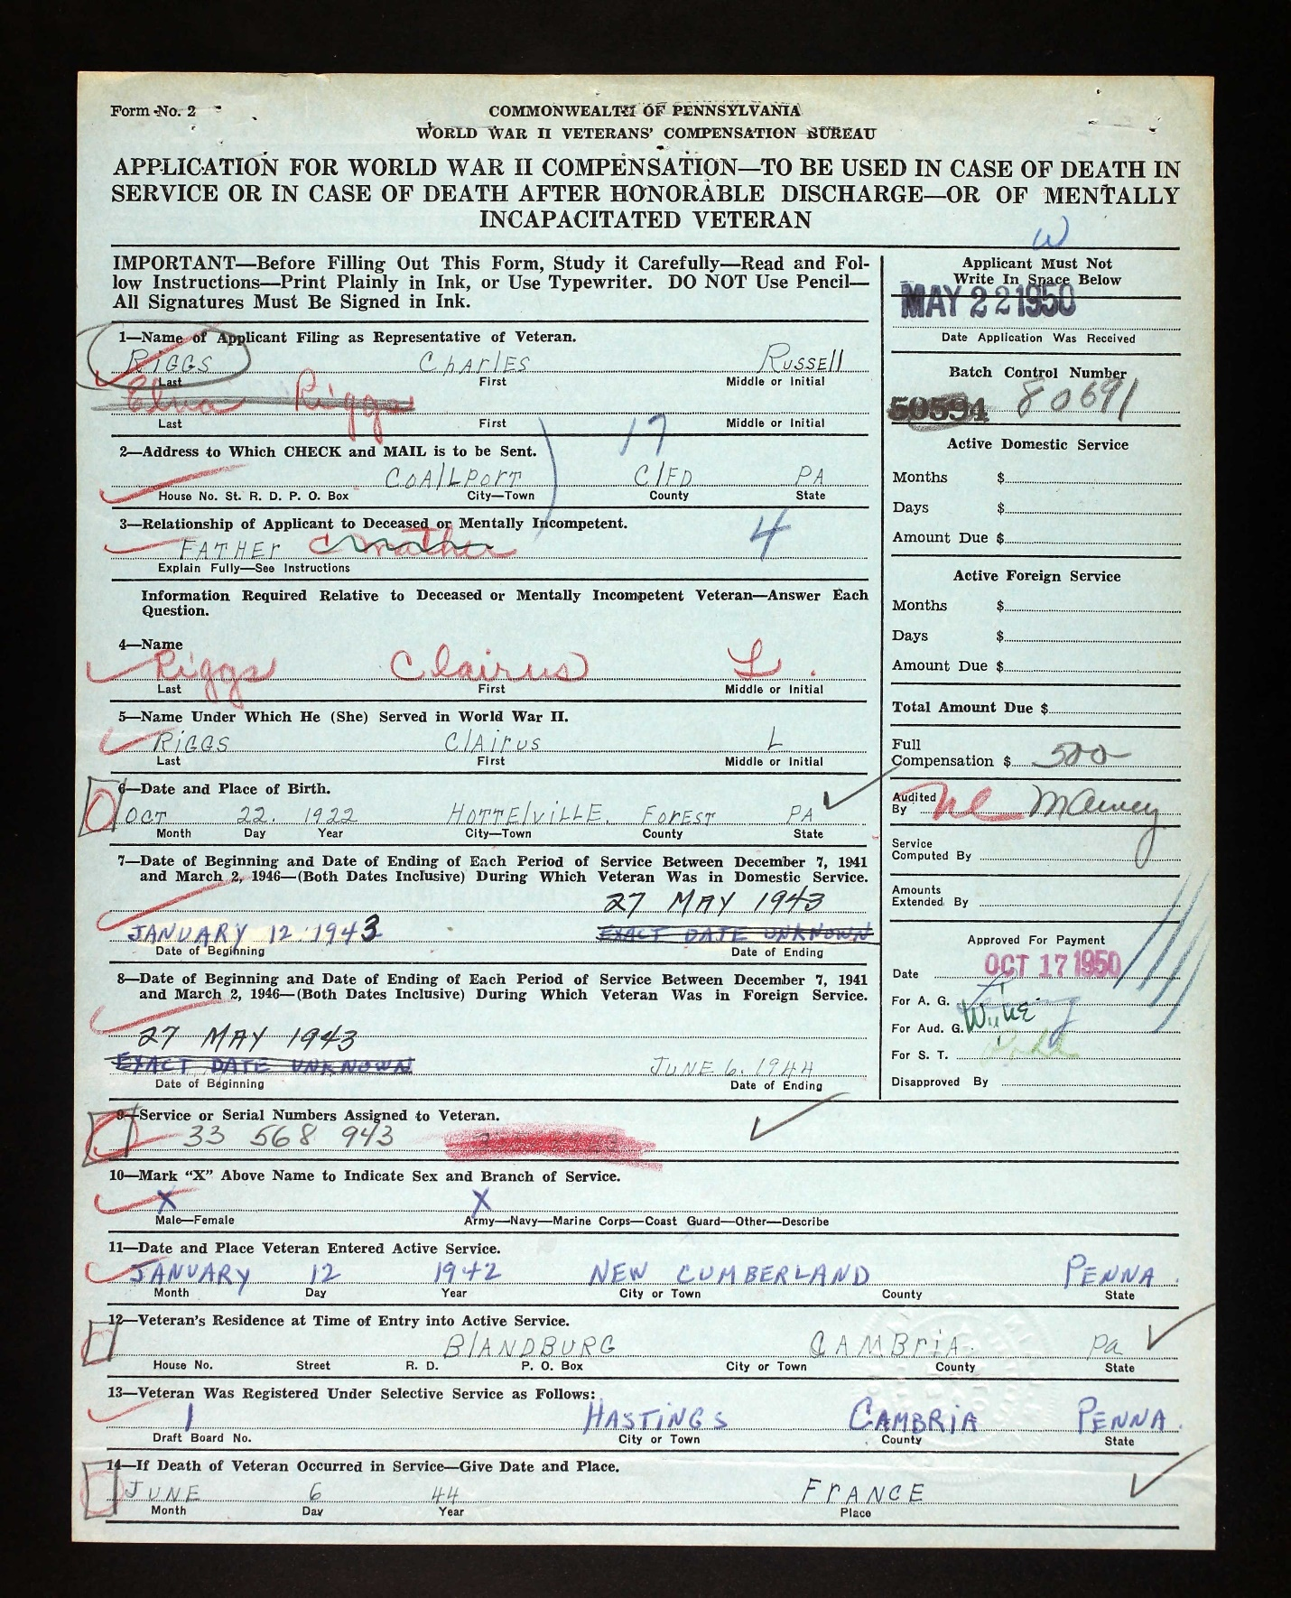
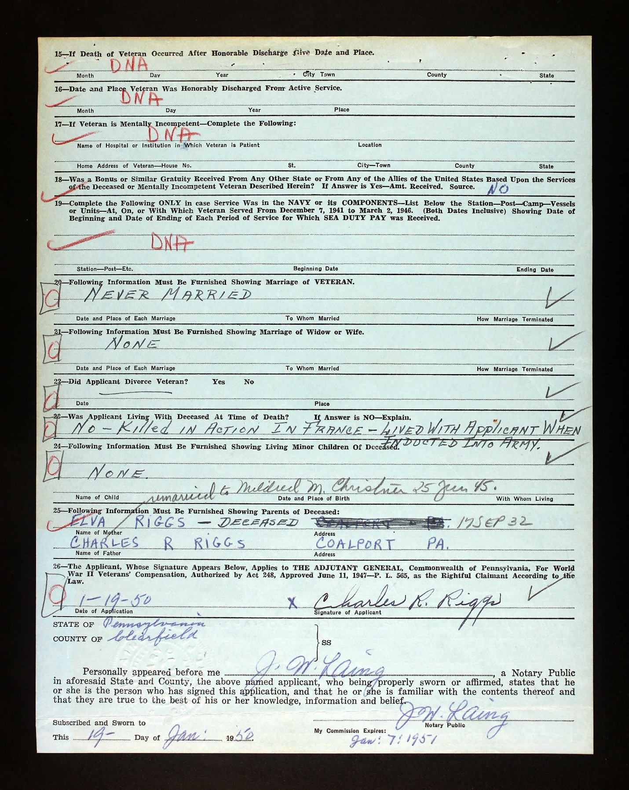

The Evening Sun, December 15, 1947
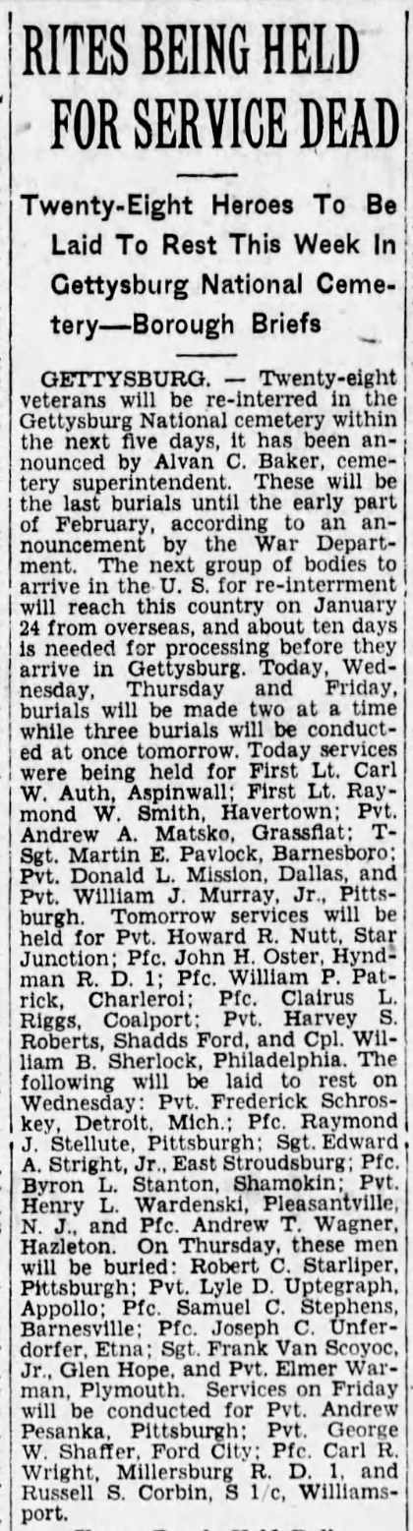

National Cemetery Interment Form
